Kubernetes Task-08
- Create and Test a Kubernetes Pod with an EmptyDir Volume
- Configure a HostPath Volume in Kubernetes and Validate Data Persistence
- Deploy an Amazon EBS Volume Using Persistent Volume and Persistent Volume Claim (PVC)
- Set Up an Amazon EFS Volume and Attach it to Multiple Pods
- Implement and Test Liveness and Readiness Probes in a Kubernetes Pod

TASK 1 — EmptyDir Volume
Objective
Create a Pod with an emptyDir volume, write data into it, verify the data, delete/recreate the Pod, and understand what happens to the data.
Step 1: Check your cluster
Run on your control-plane node:
kubectl get nodes -o wide
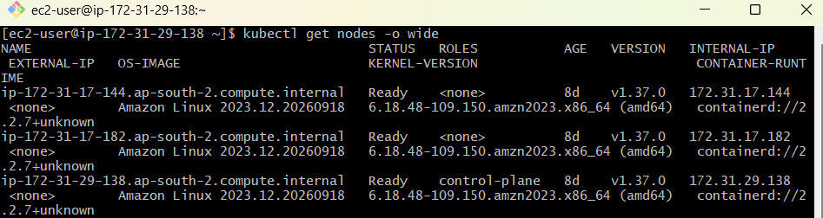
You should see something similar to:
NAME STATUS ROLES INTERNAL-IP
ip-172.31.29.138 Ready control-plane 172.31.29.138
ip-172.31.17.144 Ready <none> 172.31.17.144
Also check:
kubectl get pods -A
Make sure your cluster is healthy.
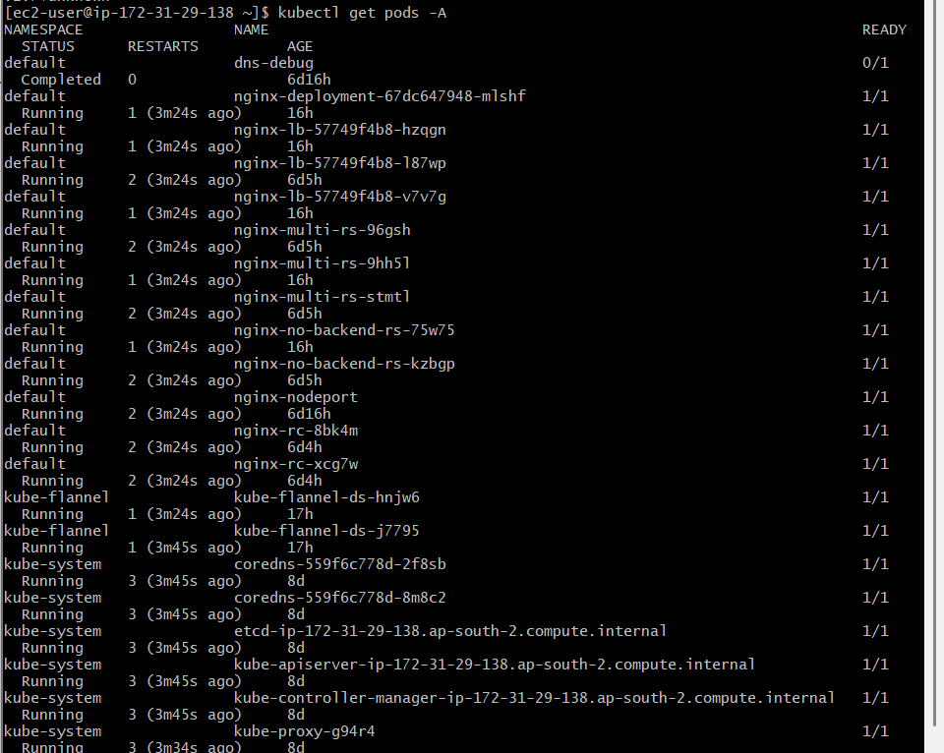

Step 2: Create YAML
Create:
vi emptydir-pod.yaml
Add:
apiVersion: v1
kind: Pod
metadata:
name: emptydir-pod
spec:
containers:
- name: nginx
image: nginx:latest
volumeMounts:
- name: shared-storage
mountPath: /usr/share/nginx/html

volumes:
- name: shared-storage
emptyDir: {}
Save:
:wq

Step 3: Create the Pod
kubectl apply -f emptydir-pod.yaml
Check:
kubectl get pod emptydir-pod -o wide
Expected:
NAME READY STATUS RESTARTS AGE
emptydir-pod 1/1 Running 0 ...
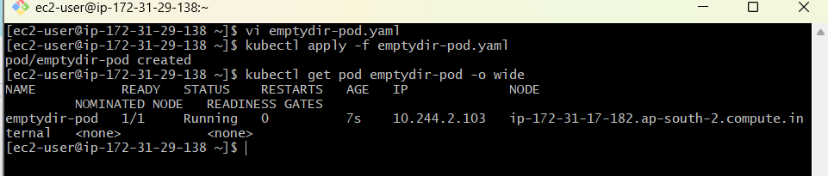

Step 4: Write data into EmptyDir
Run:
kubectl exec emptydir-pod -- sh -c 'echo "Hello from EmptyDir" > /usr/share/nginx/html/index.html'
Read it:
kubectl exec emptydir-pod -- cat /usr/share/nginx/html/index.html
Expected:
Hello from EmptyDir
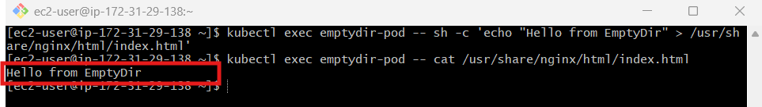

Step 5: Verify volume
kubectl exec emptydir-pod -- df -h /usr/share/nginx/html
You can also inspect the Pod:
kubectl describe pod emptydir-pod
Look for:
Volumes:
shared-storage:
Type: EmptyDir
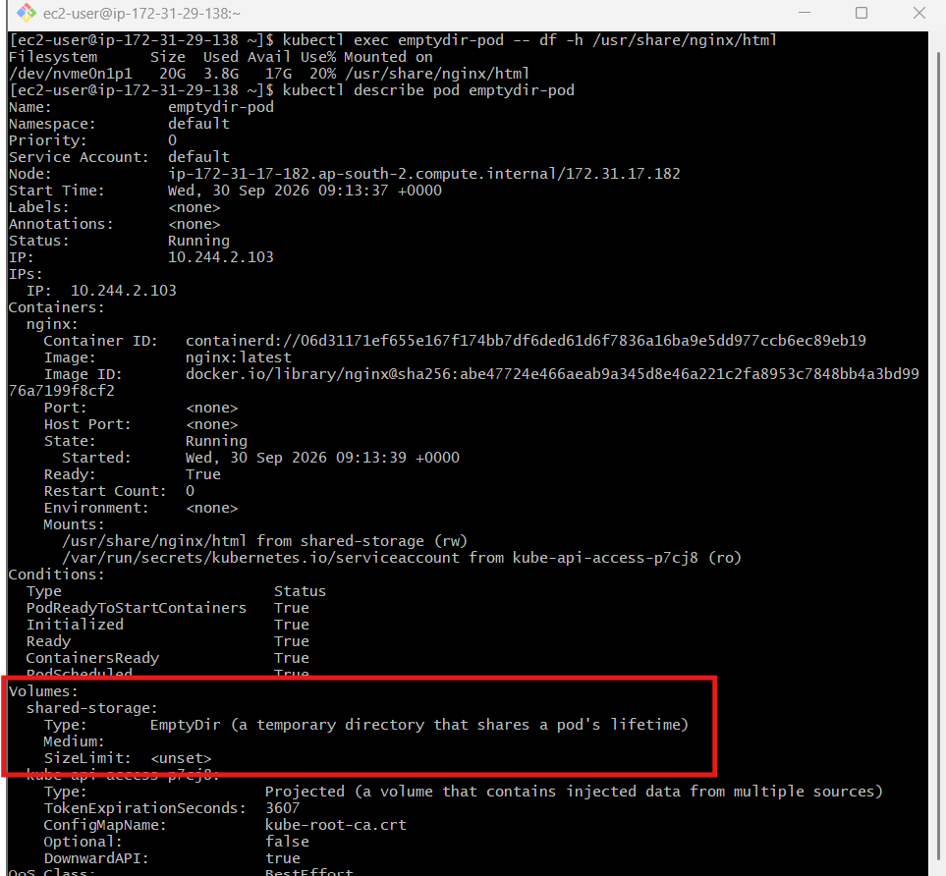

Step 6: Delete the Pod
kubectl delete pod emptydir-pod
Create it again:
kubectl apply -f emptydir-pod.yaml
Check:
kubectl exec emptydir-pod -- ls -l /usr/share/nginx/html
The file you created earlier will be gone.
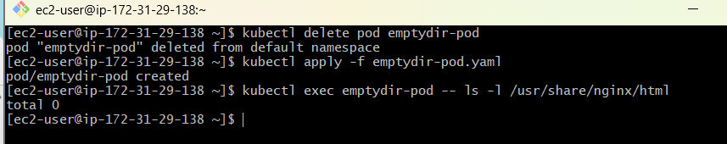
Why?
emptyDir exists only for the lifetime of the Pod.
Pod starts
↓
emptyDir created
↓
Pod writes data
↓
Pod deleted
↓
emptyDir deleted
↓
Data lost

TASK 2 — HostPath Volume
Objective
Mount a directory from the Kubernetes node into a Pod.
The important difference:
emptyDir
↓
Pod lifetime

hostPath
↓
Node filesystem

Step 1: Find the node where the Pod runs
Create:
vi hostpath-pod.yaml
Use:
apiVersion: v1
kind: Pod
metadata:
name: hostpath-pod
spec:
containers:
- name: nginx
image: nginx:latest
volumeMounts:
- name: host-storage
mountPath: /usr/share/nginx/html

volumes:
- name: host-storage
hostPath:
path: /data/k8s
type: DirectoryOrCreate
Apply:
kubectl apply -f hostpath-pod.yaml
Check:
kubectl get pod hostpath-pod -o wide
Example:
NAME READY STATUS NODE
hostpath-pod 1/1 Running ip-172-31-17-144
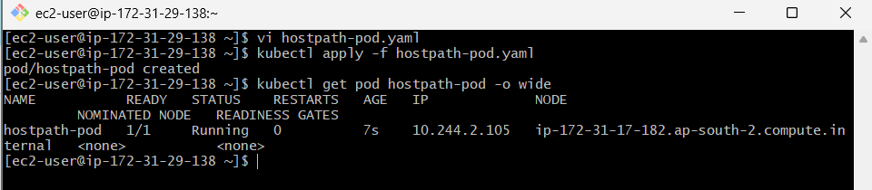

Step 2: Create data inside the Pod
kubectl exec hostpath-pod -- sh -c 'echo "HostPath Persistent Data" > /usr/share/nginx/html/data.txt'
Verify:
kubectl exec hostpath-pod -- cat /usr/share/nginx/html/data.txt
Expected:
HostPath Persistent Data
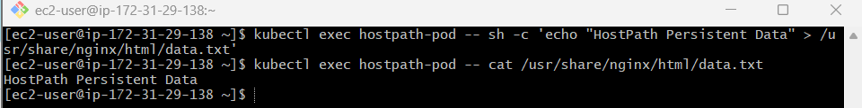

Step 3: Find the node
kubectl get pod hostpath-pod -o wide
Suppose:
NODE
ip-172-31-17-144
SSH into that worker node.
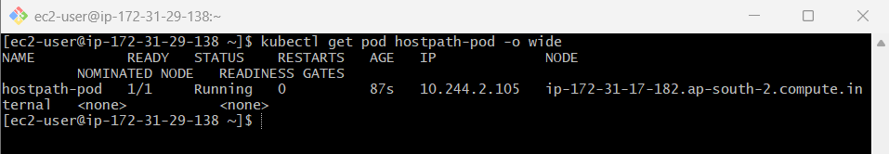
Then:
sudo ls -l /data/k8s
You should see:
data.txt
Check:
sudo cat /data/k8s/data.txt
Expected:
HostPath Persistent Data
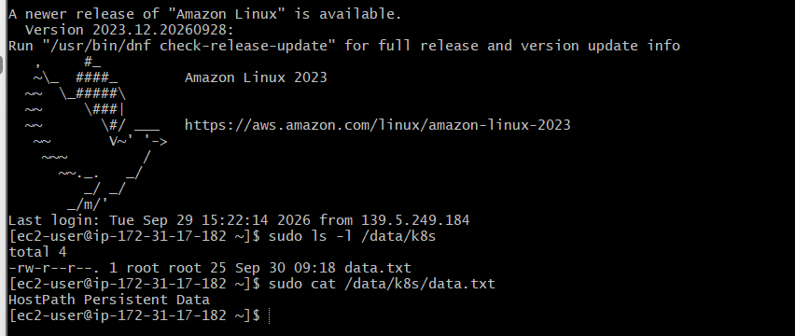

Step 4: Delete the Pod
kubectl delete pod hostpath-pod
Create again:
kubectl apply -f hostpath-pod.yaml
Check:
kubectl exec hostpath-pod -- cat /usr/share/nginx/html/data.txt
You may see:
HostPath Persistent Data
because the data remains on the node.
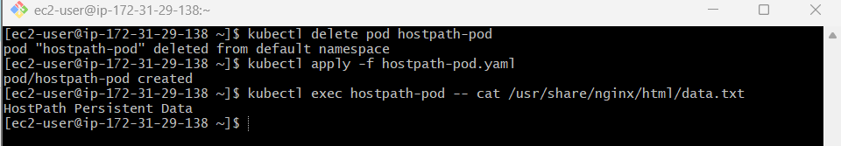
Important interview point
hostPath is generally not recommended for production application storage because the data belongs to a particular Kubernetes node.
For example:
Pod
↓
Worker Node A
↓
/data/k8s
If Kubernetes moves the Pod:
Pod
↓
Worker Node B
↓
/data/k8s
Node B may not have the original data.

TASK 3 — Amazon EBS + PV + PVC
What we are going to accomplish
By the end, you will have:
- EBS CSI Driver ✅
- StorageClass ✅
- PVC ✅
- Dynamically created PV ✅
- AWS EBS volume ✅
- Pod using EBS ✅
- Data written to EBS ✅
- Pod deleted/recreated ✅
- Data verified as persistent ✅

Step 0 — Confirm prerequisites
You already completed these, but verify once:
kubectl get nodes
Expected:
NAME STATUS ROLES
ip-172-31-29-138 Ready control-plane
ip-172-31-17-144 Ready <none>
ip-172-31-17-182 Ready <none>
Then:
kubectl get csidrivers
Expected:
NAME
ebs.csi.aws.com
Then:
kubectl get pods -n kube-system | grep ebs-csi
You should have the controller and node components running.
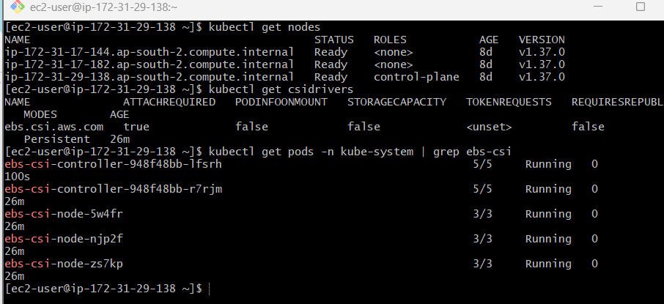

Step 1 — Create the EBS StorageClass
A StorageClass tells Kubernetes how storage should be dynamically created.
Create:
vi ebs-storageclass.yaml
Paste:
apiVersion: storage.k8s.io/v1
kind: StorageClass
metadata:
name: ebs-sc
provisioner: ebs.csi.aws.com
parameters:
type: gp3
fsType: ext4
volumeBindingMode: WaitForFirstConsumer
reclaimPolicy: Delete
Save:
Esc
:wq
Enter
Apply:
kubectl apply -f ebs-storageclass.yaml
Expected:
storageclass.storage.k8s.io/ebs-sc created
Verify:
kubectl get storageclass
Expected:
NAME PROVISIONER RECLAIMPOLICY VOLUMEBINDINGMODE
ebs-sc ebs.csi.aws.com Delete WaitForFirstConsumer
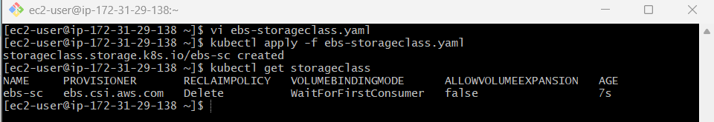
Important
WaitForFirstConsumer means:
PVC created
↓
Wait
↓
Pod created
↓
Scheduler chooses node
↓
EBS CSI creates EBS in correct AZ
↓
PV created/bound
This is particularly useful with EBS because EBS volumes are Availability-Zone specific.

Step 2 — Create the PersistentVolumeClaim
Now create the PVC.
vi ebs-pvc.yaml
Paste:
apiVersion: v1
kind: PersistentVolumeClaim
metadata:
name: ebs-claim
spec:
accessModes:
- ReadWriteOnce
storageClassName: ebs-sc
resources:
requests:
storage: 5Gi
Save:
Esc
:wq
Enter
Apply:
kubectl apply -f ebs-pvc.yaml
Expected:
persistentvolumeclaim/ebs-claim created
Check:
kubectl get pvc
You may see:
NAME STATUS VOLUME CAPACITY ACCESS MODES STORAGECLASS
ebs-claim Pending ebs-sc
⚠️ Don't worry if it says Pending
This is expected.
Why?
Because we configured:
volumeBindingMode: WaitForFirstConsumer
Kubernetes is waiting for a Pod that actually consumes this PVC.
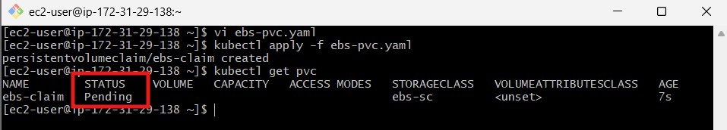

Step 3 — Create the Pod
Now we'll create an Nginx Pod that mounts the EBS volume at:
/data
Create:
vi ebs-pod.yaml
Paste:
apiVersion: v1
kind: Pod
metadata:
name: ebs-test-pod
spec:
containers:
- name: nginx
image: nginx:latest
volumeMounts:
- name: ebs-storage
mountPath: /data
volumes:
- name: ebs-storage
persistentVolumeClaim:
claimName: ebs-claim
Save:
Esc
:wq
Enter
Apply:
kubectl apply -f ebs-pod.yaml
Expected:
pod/ebs-test-pod created
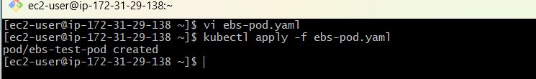

Step 4 — Check the Pod
Run:
kubectl get pod -o wide
Expected:
NAME READY STATUS RESTARTS AGE IP
ebs-test-pod 1/1 Running 0 ... ...
Also check:
kubectl get pvc
Now you should see:
NAME STATUS VOLUME CAPACITY ACCESS MODES STORAGECLASS
ebs-claim Bound pvc-xxxxxxxx-xxxx-xxxx-xxxx-xxxxxxxxxxxx 5Gi RWO ebs-sc
And:
kubectl get pv
You should see something similar to:
NAME CAPACITY ACCESS MODES RECLAIM POLICY
pvc-xxxxxxxx-xxxx-xxxx-xxxx-xxxxxxxxxxxx 5Gi RWO Delete
🎉 This is the important moment.
Kubernetes has dynamically created:
PVC
↓
PV
↓
AWS EBS
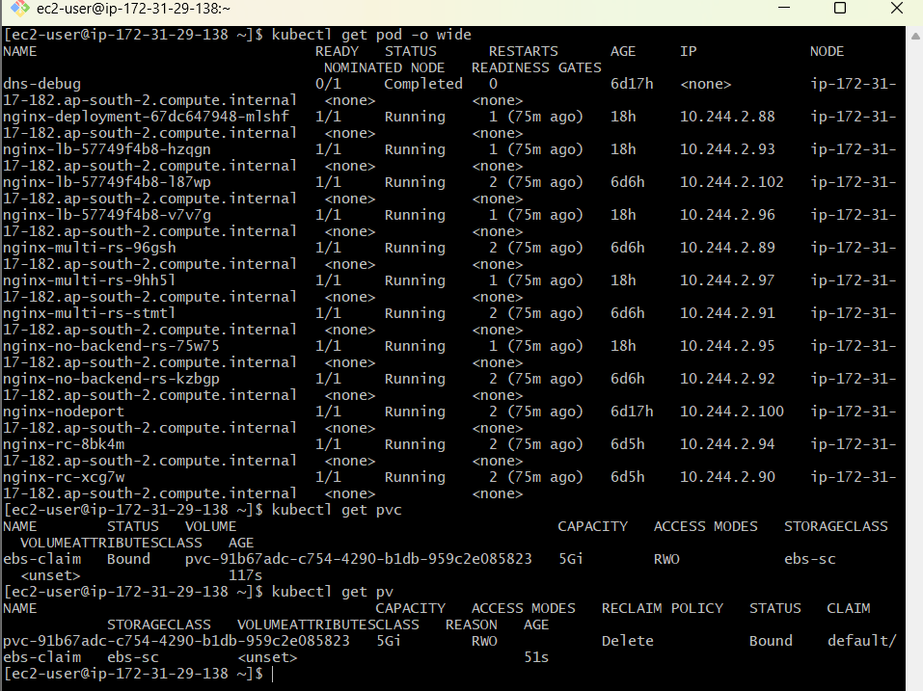

Step 5 — Inspect the PV
Run:
kubectl get pv
Copy the PV name.
Then:
kubectl describe pv <PV-NAME>
For example:
kubectl describe pv pvc-xxxxxxxx-xxxx-xxxx-xxxx-xxxxxxxxxxxx
Look for:
StorageClass: ebs-sc
Status: Bound
Claim: default/ebs-claim
Reclaim Policy: Delete
Access Modes: RWO
Most importantly, look for:
Source:
Type: CSI
Driver: ebs.csi.aws.com
VolumeHandle: vol-xxxxxxxxxxxxxxxxx
The:
vol-xxxxxxxxxxxxxxxxx
is the actual AWS EBS Volume ID.
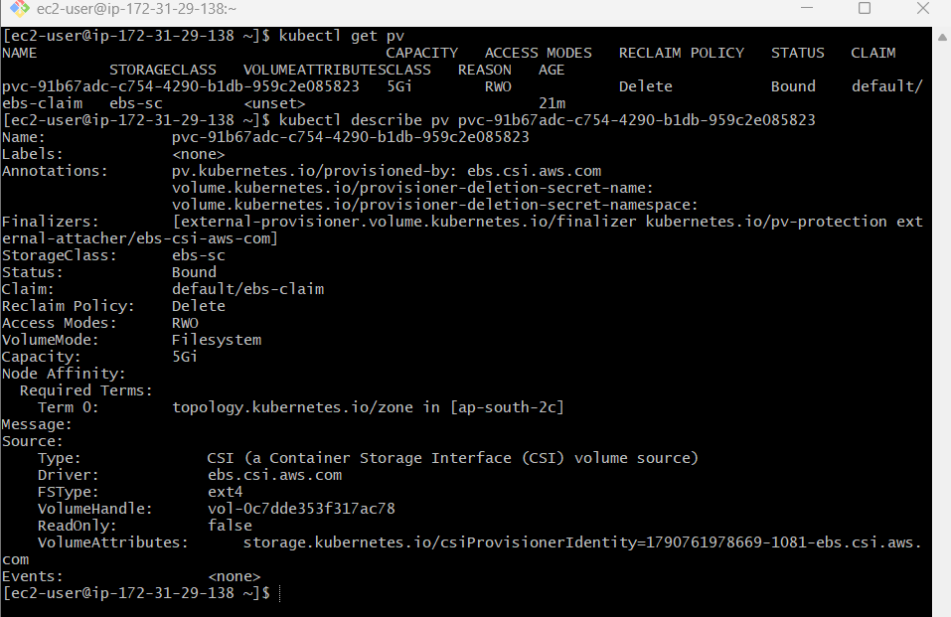

Step 6 — Verify the EBS volume in AWS
Get the volume ID directly:
kubectl get pv <PV-NAME> -o jsonpath='{.spec.csi.volumeHandle}'; echo
Example:
vol-0123456789abcdef0
Store it:
VOLUME_ID=$(kubectl get pv <PV-NAME> -o jsonpath='{.spec.csi.volumeHandle}')
echo $VOLUME_ID
Then:
aws ec2 describe-volumes \
--volume-ids $VOLUME_ID \
--query 'Volumes[0].[VolumeId,Size,VolumeType,AvailabilityZone,State]' \
--output table
You should see something like:
------------------------------------------------
| DescribeVolumes |
+----------------------+-----------------------+
| vol-0123456789... | 5 |
| gp3 | ap-south-2c |
| in-use | |
+----------------------+-----------------------+
This proves the Kubernetes PVC resulted in a real AWS EBS volume.
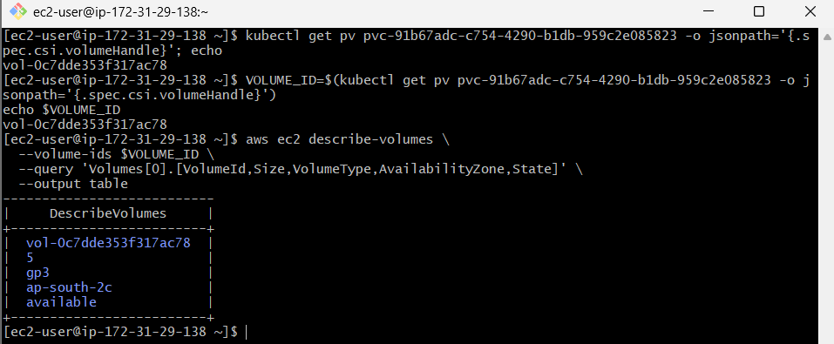

Step 7 — Check where the Pod is running
Run:
kubectl get pod ebs-test-pod -o wide
Example:
NAME READY STATUS NODE
ebs-test-pod 1/1 Running ip-172-31-17-182
Remember:
172.31.17.182 → ap-south-2c
So the EBS volume is also created in:
ap-south-2c
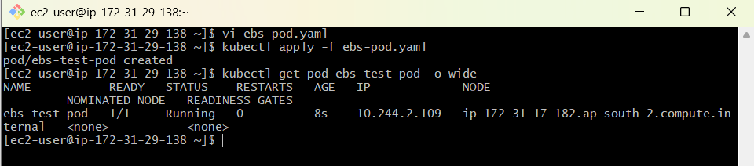

Step 8 — Verify the mounted EBS filesystem
Enter the Pod:
kubectl exec -it ebs-test-pod -- bash
Inside the container:
df -h
You should see /data.
Then:
mount | grep /data
Also:
ls -la /data
Now create a test file:
echo "Hello from Kubernetes EBS" > /data/test.txt
Verify:
cat /data/test.txt
Expected:
Hello from Kubernetes EBS
Exit:
exit
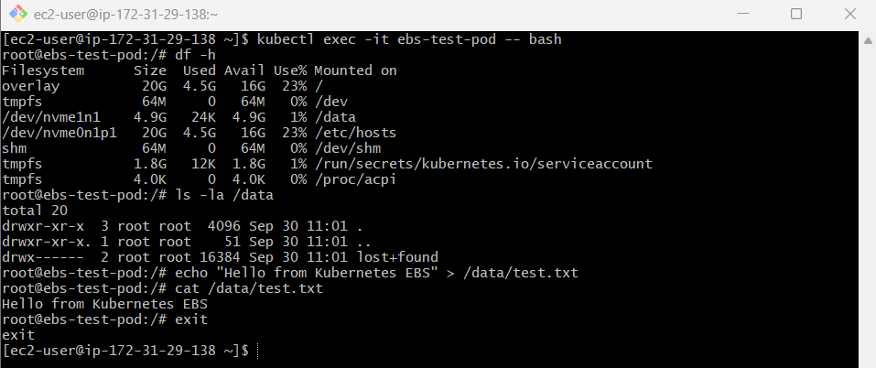

Step 9 — Test EBS persistence
This is the most important part of the lab.
Delete the Pod:
kubectl delete pod ebs-test-pod
Expected:
pod "ebs-test-pod" deleted
Check:
kubectl get pods
The Pod should disappear.
The PVC should still exist:
kubectl get pvc
Expected:
NAME STATUS VOLUME CAPACITY
ebs-claim Bound pvc-... 5Gi
And:
kubectl get pv
should still show the PV.
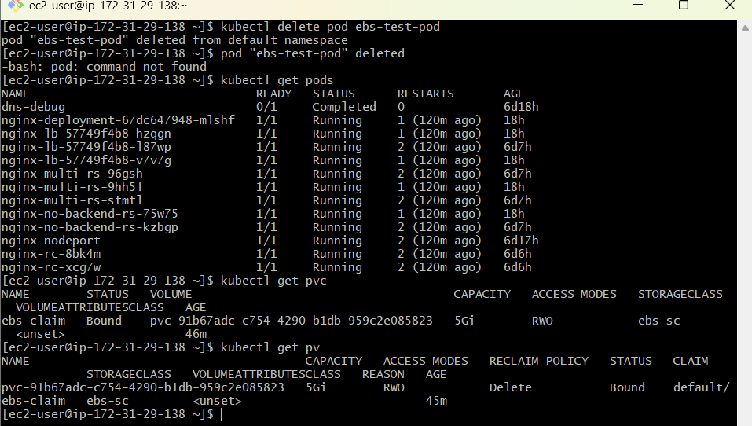

Step 10 — Recreate the Pod
Run:
kubectl apply -f ebs-pod.yaml
Wait:
kubectl get pod -o wide
Once it becomes:
1/1 Running
enter it:
kubectl exec -it ebs-test-pod -- bash
Check:
cat /data/test.txt
Expected:
Hello from Kubernetes EBS
🎉 This proves persistence.
The Pod was deleted, but the data remained because the data was stored on the EBS volume rather than inside the container filesystem.
Exit:
exit
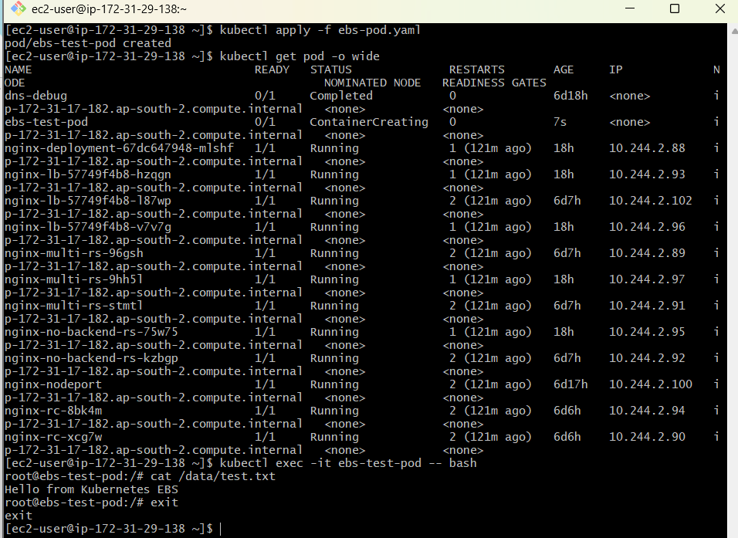

Step 11 — Final verification
Run all these:
kubectl get storageclass
kubectl get pvc
kubectl get pv
kubectl get pod -o wide
And:
kubectl get pv -o wide
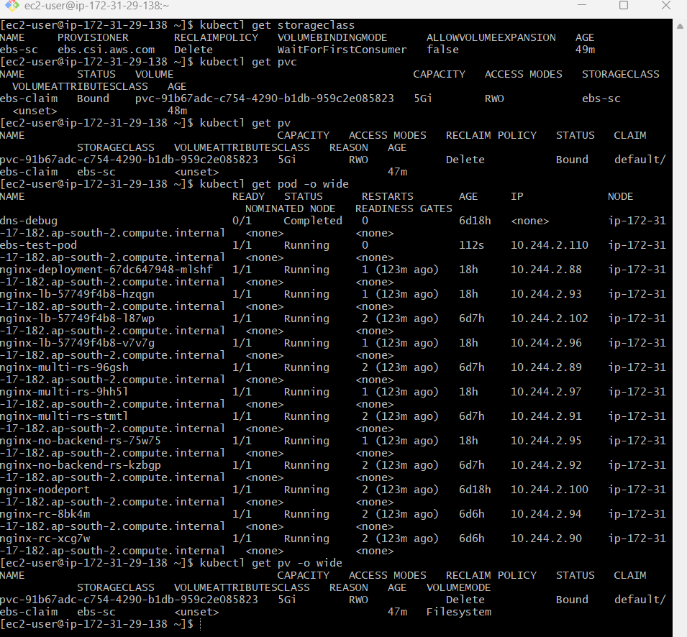
You should have this relationship:
StorageClass
│
│ ebs-sc
▼
PVC
│
│ ebs-claim
▼
PV
│
│ ebs.csi.aws.com
▼
AWS EBS
│
│ 5 GiB gp3
▼
Pod
│
│ /data
▼
test.txt

Step 12 — Understand the complete EBS flow
For your Kubernetes demo/interview, remember this:
1. Admin creates StorageClass
ebs-sc
It tells Kubernetes:
Use the AWS EBS CSI driver to provision gp3 storage.
2. Developer creates PVC
ebs-claim
5Gi
RWO
PVC says:
I need 5 GiB of persistent storage.
3. Pod requests PVC
persistentVolumeClaim:
claimName: ebs-claim
4. Kubernetes scheduler selects a node
Because we use:
WaitForFirstConsumer
Kubernetes considers the Pod's scheduling requirements and storage topology.
5. EBS CSI Driver provisions EBS
Kubernetes
↓
EBS CSI Driver
↓
AWS API
↓
EBS gp3 Volume
6. Kubernetes creates PV
The PV represents the actual persistent storage resource.
7. EBS gets attached to the EC2 worker
EBS
↓
EC2 Worker
↓
Pod
8. Pod mounts it
EBS → /data
9. Data survives Pod deletion
Pod 1
│
└── /data/test.txt
│
▼
EBS Volume
│
▼
Pod 2
│
└── /data/test.txt

Important concepts for your interview
PV vs PVC
Component | Meaning
PV | Actual storage resource available to Kubernetes
PVC | Request for storage
StorageClass | Defines how storage is provisioned
CSI Driver | Connects Kubernetes to the storage provider
EBS | AWS block storage
Simple memory trick:
StorageClass = HOW
PVC = I NEED
PV = STORAGE
CSI Driver = CONNECTOR
EBS = ACTUAL AWS DISK

EBS Access Mode
We're using:
accessModes:
- ReadWriteOnce
Meaning:
The volume can be mounted read-write by a single node at a time.
This is an important difference from EFS.
For your next task:
EBS → generally RWO / block storage
EFS → shared filesystem / multiple Pods

Step 13 — Final EBS verification
Run these commands:
13.1 StorageClass
kubectl get storageclass
Expected:
NAME PROVISIONER RECLAIMPOLICY VOLUMEBINDINGMODE
ebs-sc ebs.csi.aws.com Delete WaitForFirstConsumer
13.2 PVC
kubectl get pvc
Expected:
NAME STATUS VOLUME CAPACITY ACCESS MODES
ebs-claim Bound pvc-91b67adc-c754-4290-b1db-959c2e085823 5Gi RWO
13.3 PV
kubectl get pv
Expected:
NAME CAPACITY ACCESS MODES RECLAIM POLICY STATUS CLAIM
pvc-91b67adc-c754-4290-b1db-959c2e085823 5Gi RWO Delete Bound default/ebs-claim
13.4 Pod
kubectl get pod ebs-test-pod -o wide
Expected:
NAME READY STATUS RESTARTS AGE IP NODE
ebs-test-pod 1/1 Running 0 ... 10.244.x.x ip-172-31-17-182
13.5 PV details
kubectl get pv -o wide
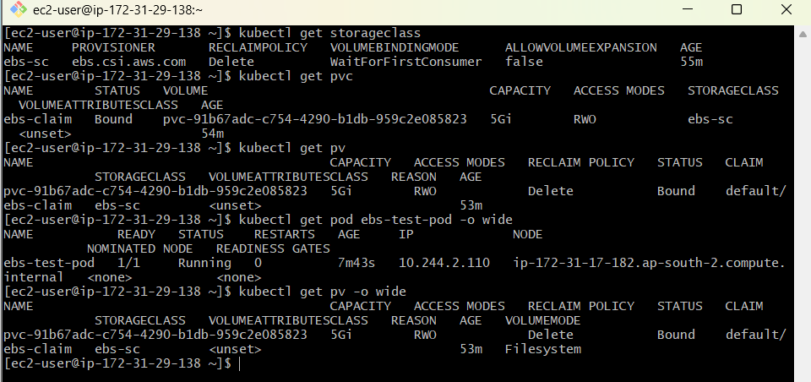

Step 14 — Verify the EBS Volume in AWS
Get the actual EBS Volume ID:
kubectl get pv pvc-91b67adc-c754-4290-b1db-959c2e085823 \
-o jsonpath='{.spec.csi.volumeHandle}'; echo
You'll get something like:
vol-0123456789abcdef0
Set it as a variable:
VOLUME_ID=$(kubectl get pv pvc-91b67adc-c754-4290-b1db-959c2e085823 \
-o jsonpath='{.spec.csi.volumeHandle}')
Then:
aws ec2 describe-volumes \
--volume-ids "$VOLUME_ID" \
--query 'Volumes[0].[VolumeId,Size,VolumeType,AvailabilityZone,State]' \
--output table
You should see:
5
gp3
ap-south-2c
in-use
This gives you AWS-side proof that the Kubernetes PV is backed by a real EBS volume.
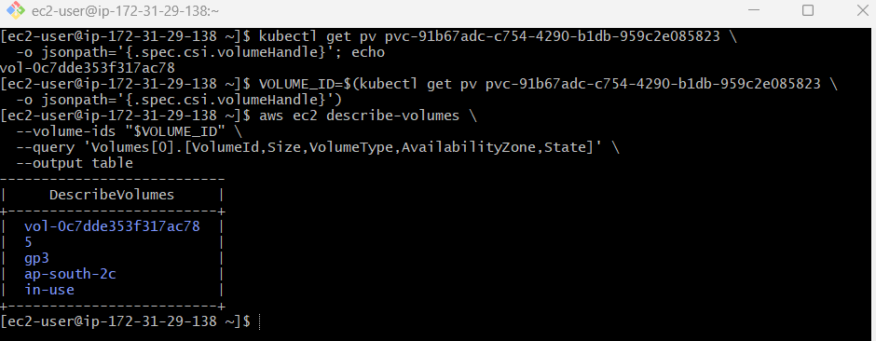

Step 15 — Verify the data
Enter the Pod:
kubectl exec -it ebs-test-pod -- bash
Check the mount:
df -h /data
Check the file:
ls -l /data
Then:
cat /data/test.txt
Expected:
Hello from Kubernetes EBS
Exit:
exit
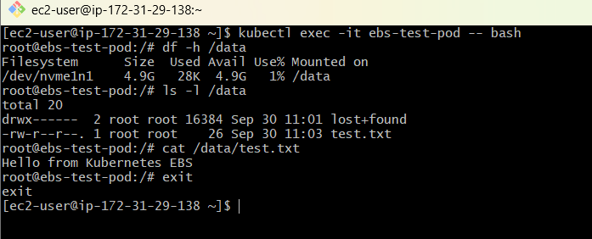

Step 16 — Final persistence test
This is the final practical test for Task 3.
Delete only the Pod:
kubectl delete pod ebs-test-pod
Confirm:
kubectl get pod
The Pod should be gone.
Do NOT delete:
❌ ebs-claim
❌ PV
❌ EBS volume
Now recreate the Pod:
kubectl apply -f ebs-pod.yaml
Wait:
kubectl get pod ebs-test-pod -o wide
Wait until:
1/1 Running
Then verify the data:
kubectl exec -it ebs-test-pod -- cat /data/test.txt
Expected:
Hello from Kubernetes EBS
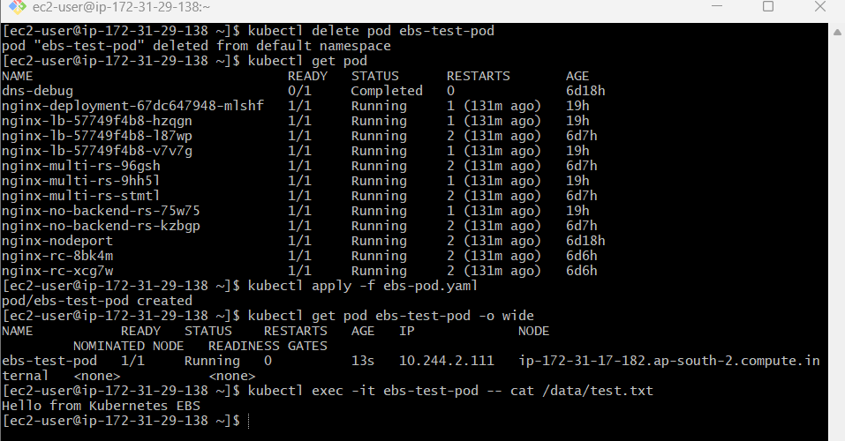

TASK 4 — Amazon EFS + Multiple Pods
This is where you learn shared storage.
Unlike EBS:
EBS
↓
Typically one node at a time
↓
ReadWriteOnce
EFS is designed for shared filesystem access:
EFS
/ \
/ \
Pod A Pod B
| |
+-----+-----+
|
Same files
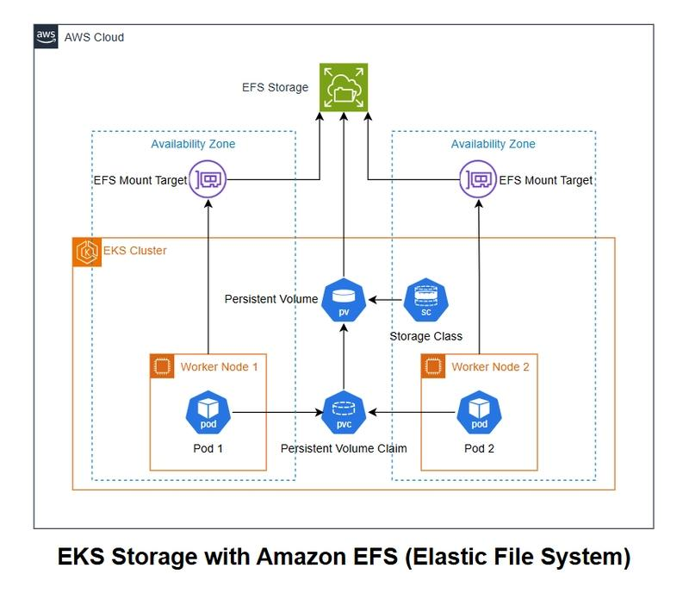
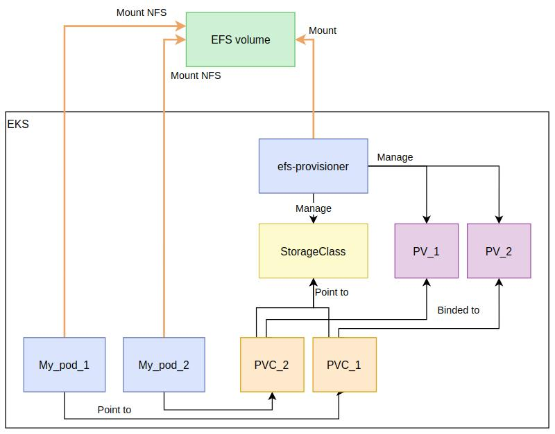
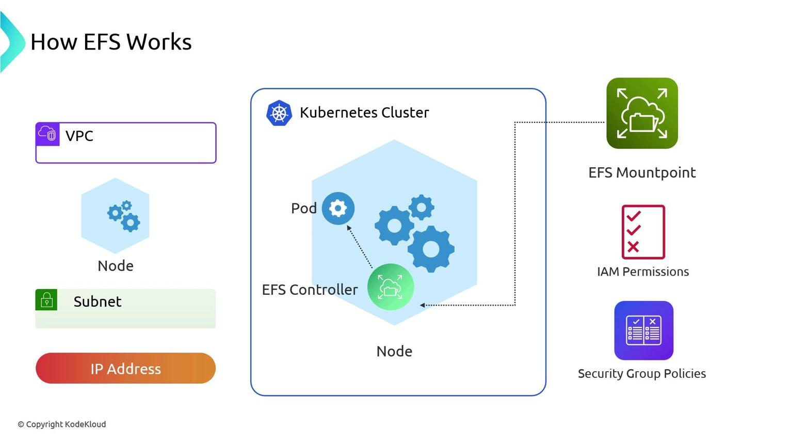
5

Step 4A — Check EFS CSI driver
Run:
kubectl get pods -n kube-system | grep efs
And:
kubectl get csidrivers
You should see:
efs.csi.aws.com
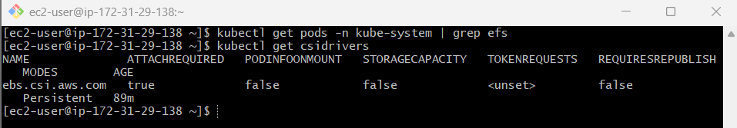

Step 4B — Create EFS filesystem
Using AWS CLI, first create the filesystem:
aws efs create-file-system \
--creation-token kubernetes-efs-demo
You'll get:
FileSystemId: fs-xxxxxxxx
Record it.
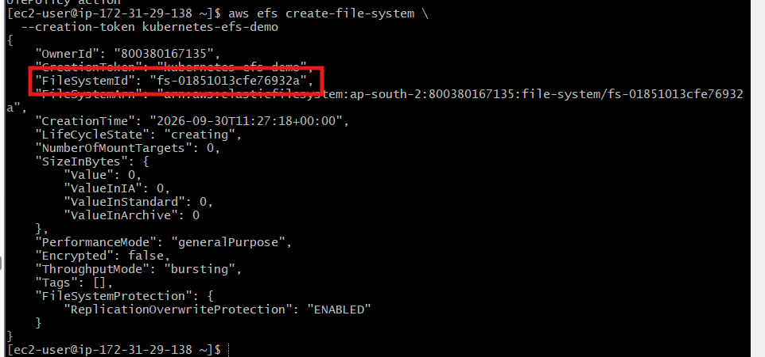

Step 4C — Create EFS access point
For a simple lab, an EFS Access Point is a good approach.
You can create one using AWS CLI:
aws efs create-access-point \
--file-system-id fs-xxxxxxxx \
--posix-user Uid=1000,Gid=1000 \
--root-directory Path=/k8sdata,CreationInfo="{OwnerUid=1000,OwnerGid=1000,Permissions=755}"
Record:
AccessPointId
For example:
fsap-0c73711c4fbdf7f0b
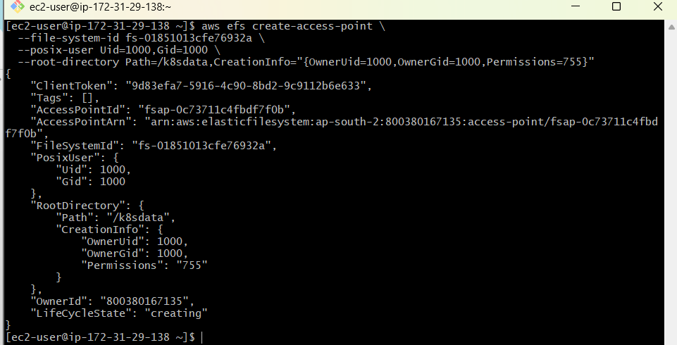

Step 4D — Create EFS StorageClass
Create:
vi efs-storageclass.yaml
apiVersion: storage.k8s.io/v1
kind: StorageClass
metadata:
name: efs-sc

provisioner: efs.csi.aws.com

parameters:
provisioningMode: efs-ap
fileSystemId: fs-xxxxxxxx
directoryPerms: "755"

reclaimPolicy: Retain

volumeBindingMode: Immediate
Replace:
fs-xxxxxxxx
with your EFS filesystem ID.
Apply:
kubectl apply -f efs-storageclass.yaml
Check:
kubectl get storageclass
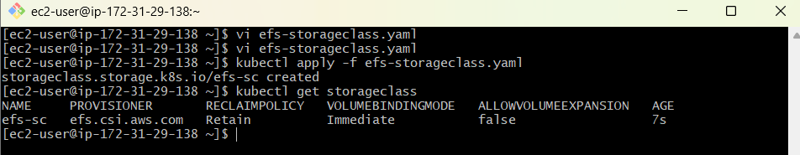

Step 4E — Create PVC
Create:
vi efs-pvc.yaml
apiVersion: v1
kind: PersistentVolumeClaim
metadata:
name: efs-pvc
spec:
accessModes:
- ReadWriteMany

storageClassName: efs-sc

resources:
requests:
storage: 5Gi
Apply:
kubectl apply -f efs-pvc.yaml
Check:
kubectl get pvc
Expected:
NAME STATUS VOLUME
efs-pvc Bound ...
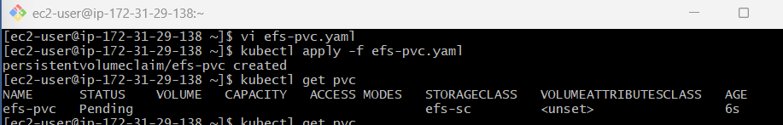
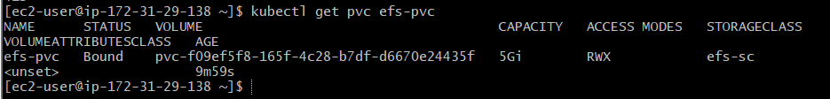

Step 4F — Create Pod 1
Create:
vi efs-pod1.yaml
apiVersion: v1
kind: Pod
metadata:
name: efs-pod1
spec:
containers:
- name: nginx
image: nginx:latest

volumeMounts:
- name: efs-storage
mountPath: /shared

volumes:
- name: efs-storage
persistentVolumeClaim:
claimName: efs-pvc
Apply:
kubectl apply -f efs-pod1.yaml
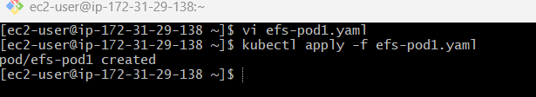

Step 4G — Create Pod 2
Create:
vi efs-pod2.yaml
apiVersion: v1
kind: Pod
metadata:
name: efs-pod2
spec:
containers:
- name: nginx
image: nginx:latest

volumeMounts:
- name: efs-storage
mountPath: /shared

volumes:
- name: efs-storage
persistentVolumeClaim:
claimName: efs-pvc
Apply:
kubectl apply -f efs-pod2.yaml
Check:
kubectl get pods -o wide
Ideally you'll see:
efs-pod1 Running node-A
efs-pod2 Running node-B
This is a great demonstration because the Pods can be on different nodes.
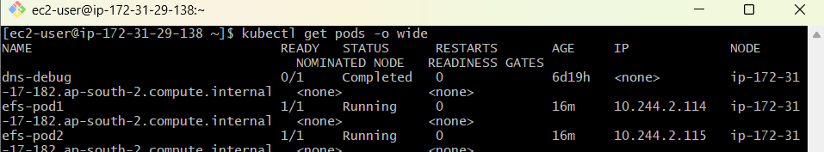

Step 4H — Write data from Pod 1
kubectl exec efs-pod1 -- sh -c 'echo "Hello from Pod 1" > /data/shared.txt'
Verify:
kubectl exec efs-pod1 -- cat /data/shared.txt
Expected:
Hello from Pod 1
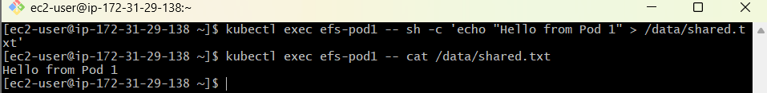

Step 4I — Read data from Pod 2
Now:
kubectl exec efs-pod2 -- cat /shared/shared.txt
Expected:
Hello from Pod 1
🎯 This is the important test.
Pod 1
|
| write
↓
EFS
↑
| read
|
Pod 2

TASK 5 — Liveness & Readiness Probes
This is extremely important for Kubernetes interviews.
There are two different questions:
Liveness
"Is my application alive?"
If liveness fails repeatedly, Kubernetes can restart the container.
Readiness
"Is my application ready to receive traffic?"
If readiness fails, Kubernetes removes the Pod from Service endpoints, but normally doesn't restart the container just because readiness failed.

Step 5A — Create Pod
Create:
vi probes-pod.yaml
Use:
apiVersion: v1
kind: Pod
metadata:
name: probes-pod

spec:
containers:
- name: nginx
image: nginx:latest

ports:
- containerPort: 80

livenessProbe:
httpGet:
path: /
port: 80
initialDelaySeconds: 10
periodSeconds: 5

readinessProbe:
httpGet:
path: /
port: 80
initialDelaySeconds: 5
periodSeconds: 5
Apply:
kubectl apply -f probes-pod.yaml

Step 5B — Check Pod
kubectl get pod probes-pod
Expected:
NAME READY STATUS
probes-pod 1/1 Running
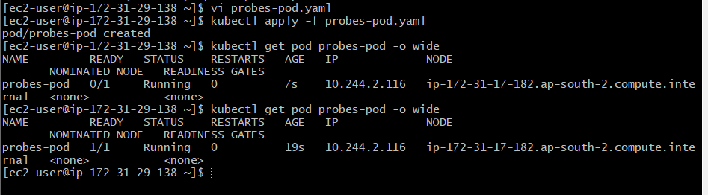

Step 5C — Describe Pod
kubectl describe pod probes-pod
Look near the bottom for:
Liveness: http-get http://:80/
Readiness: http-get http://:80/
You should also see events such as:
Liveness probe succeeded
Readiness probe succeeded
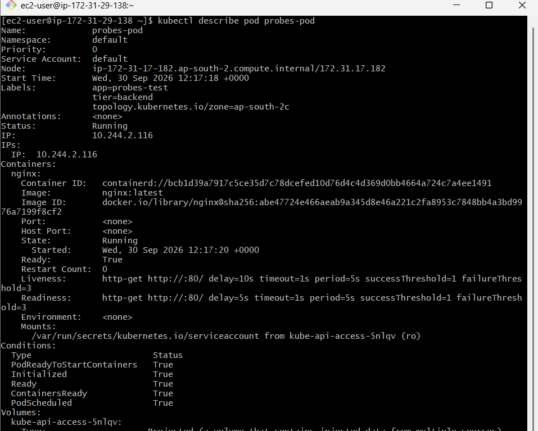

Step 5D — Test readiness failure
Now let's intentionally make nginx unable to serve HTTP.
Execute:
kubectl exec probes-pod -- sh -c 'mv /usr/share/nginx/html/index.html /usr/share/nginx/html/index.html.bak'
Depending on the image/configuration, this may not make the HTTP endpoint fail because nginx can still return a response. So for a reliable lab, it's better to deliberately change the probe endpoint.
A cleaner demonstration is to use an HTTP endpoint that you intentionally create/delete.
For example, create:
vi probe-demo.yaml
apiVersion: v1
kind: Pod
metadata:
name: probe-demo

spec:
containers:
- name: nginx
image: nginx:latest

ports:
- containerPort: 80

command:
- /bin/sh
- -c
- |
echo "Healthy Application" > /usr/share/nginx/html/healthz
nginx -g "daemon off;"

livenessProbe:
httpGet:
path: /healthz
port: 80
initialDelaySeconds: 5
periodSeconds: 5
failureThreshold: 2

readinessProbe:
httpGet:
path: /healthz
port: 80
initialDelaySeconds: 3
periodSeconds: 5
failureThreshold: 1
Apply:
kubectl apply -f probe-demo.yaml
Check:
kubectl get pod probe-demo
Expected:
READY STATUS
1/1 Running
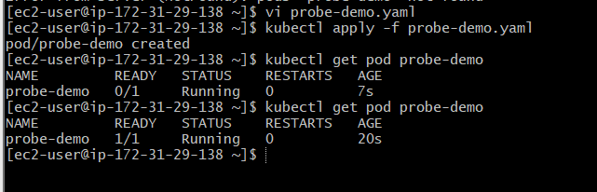

Step 5E — Break the health endpoint
Remove the health file:
kubectl exec probe-demo -- rm /usr/share/nginx/html/healthz
Now watch:
kubectl get pod probe-demo -w
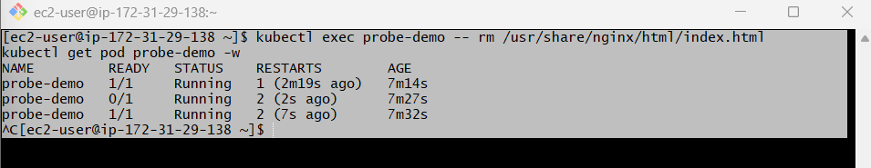
And:
kubectl describe pod probe-demo
You should see probe failures.
Because both probes are checking /healthz, the behavior demonstrates how health checks react when the endpoint becomes unavailable.

